Task – 1: Create a Policy assignment
Step 1: In this task we want to allow resources to be created in a specific location only. Hence, we are creating a policy and adding the definition of Allowed Locations. After selecting this we select the actual location allowed.
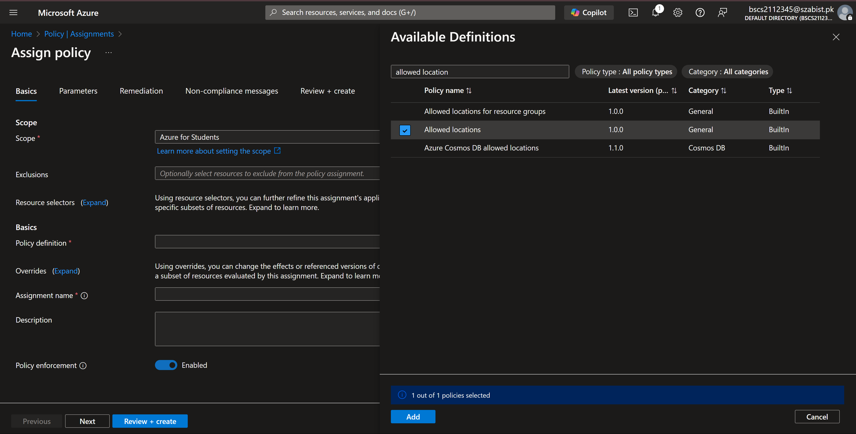
Step 2: Once the policy is validated and created it is shown in our assignments list, again policies take some time to be effective.
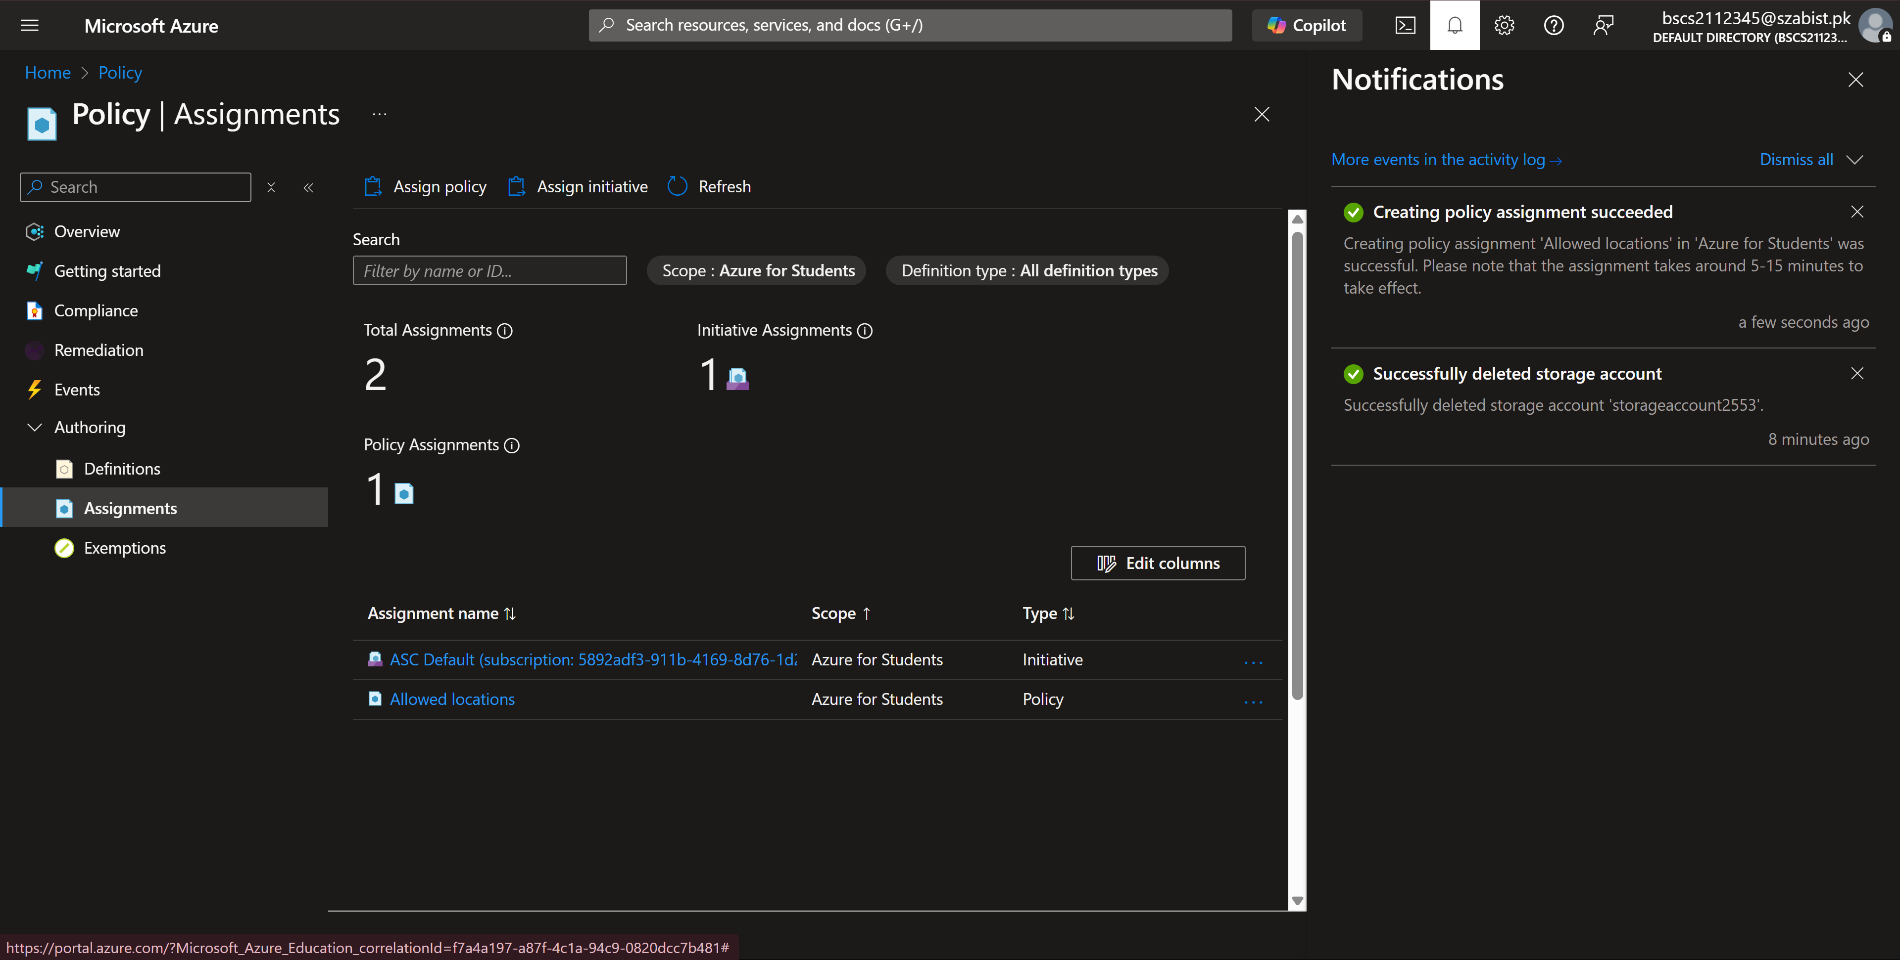

Task – 2: Test Allowed location policy
Step 1: Now to verify the policy, I’ve tried creating a storage account in “East US” and the validation fails due to our policy in which we listed “Japan West” as the allowed location.
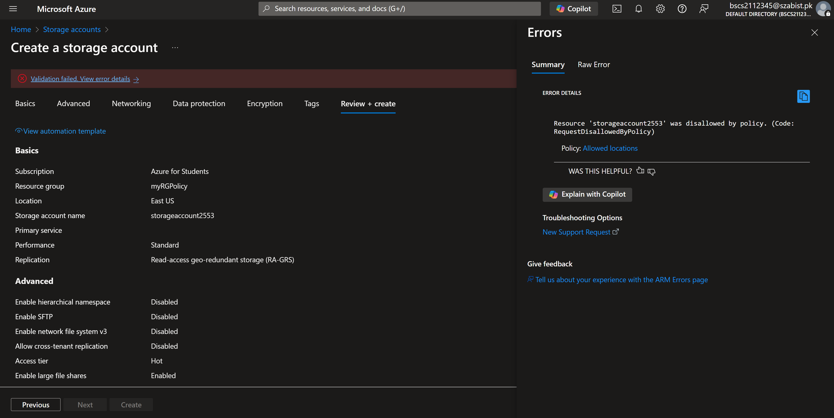
Step 2: Now we delete the policy to remove this requirement
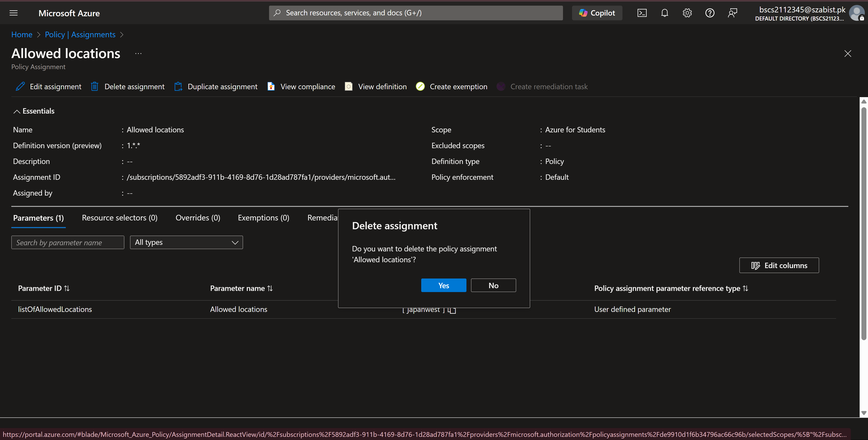

Step 3: In the last step, we can verify once the policy is removed we can created a resource in any location.
